

**SOFTWARE REQUIREMENT ENGINEERING**

**Semester Project**

**Group Members:**

**Noor Fatima (521205)**

**Noor Fatima Uzair (521214)**

**Submitted to:**

**Dr. Muhammad Younas**

**Software requirement specification:**

A Software Requirements Specification (SRS) is a document that describes the nature of a project, software or application. In simple words, an SRS document is a manual of a project provided it is prepared before you kick-start a project/application. This document is also known by the names SRS report, or software document. A software document is primarily prepared for a project, software, or any kind of application. There are a set of guidelines to be followed while preparing the software requirement specification document. This includes the purpose, scope, functional and non-functional requirements, and software and hardware requirements of the project. In addition to this, it also contains information about environmental conditions required, safety and security requirements, software quality attributes of the project, etc.

## What is a Software Requirements Specification document?

A Software requirements specification document describes the intended purpose, requirements and nature of software to be developed. It also includes the yield and cost of the software.

In this document, beauty products selling project is used as an example to explain few points.

**TABLE OF CONTENTS:**

**1.Introduction**

1.1 Purpose

1.2 Document Convention

1.3 Intended Audience and Reading Suggestions

1.4 Project Scope

1.5 References

**2.Overall Description**

2.1 Product Perspective

2.2 Product Features

2.3 User Class and Characteristics

2.4 Operating Environment

2.5 Design Implementation Constrains

2.6 Assumption and Dependencies

**3.System Feature**

3.1 Functional Requirements

**4.External Interface Requirements**

4.1 User Interface

4.2 Hardware Interfaces

4.3 Software Interfaces

4.4 Communication Interfaces

**5.Non-functional Requirements**

5.1 Performance Requirements

5.2 Safety Requirements

5.3 Security Requirements

5.4 Software Quality Attributes

**1.INTRODUCTION:**

**1.1 Purpose:**

The documents is release for website *“GLAMOASIS*”. Our website aim is to revolutionize the way customers shop for beauty products in very user friendly platform.

**1.2 Documents convention:**

This document uses the following conventions.

|  |  |
| --- | --- |
| **DB** | Database |
| **DDB** | Distributed Database |
| **ER** | Entity Relationship |

**1.3 Intended audience and reading suggestions**:

This project is the prototype for makeup selling system and it is restricted within the college premises. This has been implemented within guidance of university professor. The project is useful for makeup sellers as well as customers.

**1.4 Project scope:**

The purpose of “*GLAMOASIS*” is selling beauty products and creates convenient and easy to use applications for customers trying to buy beauty products and know details about them. The system based on a relational database management we will have database server supporting major cities of Punjab Pakistan. all we hope to provide effortless and smooth user experience along with best pricing available.

**2.OVERALL DESCRIPTION:**

**2.1 Product Perspective**

The product perceptive for a beauty product selling websites involve considering the overall context and purpose of website within makeup industry and online retail price. Here are some aspects to consider.

* **Makeup details:**

It includes all the makeup details such as all the brand details as well how and to use it.

* **Industry context:**

Understand the makeup industry landscape, trends and customer preferences analyze the market size, target audience, demographics and competitive landscape to identify opportunities and position of website accordingly.

* **Customer needs:**

Identify the specific needs, desires and pain points if the customers. Consider the factors such as convenience, variety of products, product information and enhance customers’ shopping experience

* **User friendly interface:**

Design an intuitive and visually appealing interface that is easy to navigate and showcases the products effectively. Consider the user journey from products browsing to checkouts, ensuring a seamless and engaging experience.

* **Checkout process:**

Streamline the checkout process with minimal steps, clear instructions and various payment options. After customer has completed checkout process, provide a clear and immediate order confirmation.

**2.2 Product Features:**

The product features are given in ERD diagram:

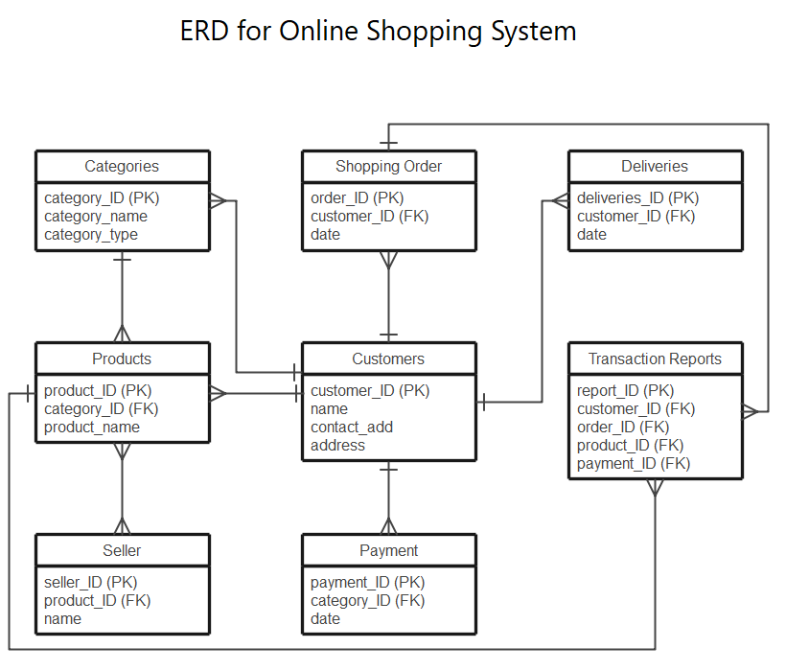

**2.3 User Class and Characteristics:**

1.Use CASE ID= UC001

2.Use case name: create account

3.Actors= customers

4.Description: the customer creates an account on makeup selling website

|  |  |  |
| --- | --- | --- |
| **Use Case steps** | **Actor action** | **System response** |
| 1. Enter details | Customers enter their name, email, phone number and password | System validate the enter detail |
| 1. Submit | Customer submits the account creation form | System creates an account and display conformation message |
| 1. Account created |  | System redirect the customer to homepage |

### Use Case ID: UC002

### Use Case Name: Browse Products

### Actors: Customer

### Description: The customer can view and search for various makeup products available on the website.

|  |  |  |
| --- | --- | --- |
| **Use case steps** | **Actor Actions** | **System response** |
| 1.Search | Customer enters search criteria or filters to narrow down the product list. | System filters and displays relevant products. |
| 2.View detail | Customer selects a specific product. | System displays detailed information on selected product. |

### 3. Use Case ID: UC003

### Use Case Name: Add to Cart

### Actors: Customer

### Description: The customer selects desired products and adds them to their shopping cart.

|  |  |  |
| --- | --- | --- |
| **Use case steps** | **Actor Actions** | **System response** |
| 1. Select Product | Customer chooses a product to add to the cart. | System retrieves the product details. |
| 2. Specify Quantity | Customer specifies the quantity of the selected products. | System validates the quantity and updates the cart with selected products and quantity. |
| 3. Add to Cart | Customer clicks on the "Add to Cart" button. | System adds the product to cart and display confirmation message. |
|  |  |  |

### 4. Use Case ID: UC004

### Use case name: View cart

### Action: customer

### Description: Customer can view cart along with individual prices and total amount. User can also remove items from cart.

### 5. Use Case ID: UC005

### Use case name: Proceed to checkout.

### Action: customer

### Description: Customer proceeds to checkout, billing information and place order.

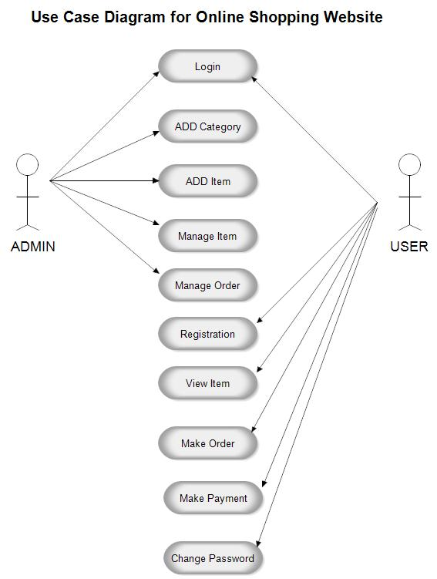

**2.4Operating Environment:**

The operating environment for the beauty products selling system is as listed below.

* distributed database
* client/server system
* Operating system: Windows.
* database: Mysql database
* platform: PHP

**2.5 DESIGN and IMPLEMENTATION CONSTRAINTS:**

Design and implementation constraints refer to limitations or restrictions that can impact the design and development of a makeup selling website.

**1. Technology Stack**: The choice of technology stack may be constrained by the existing infrastructure or the expertise of the development team. The website's features and functionalities may need to align with the capabilities of the selected technologies.

**2. Budgetary Constraints:** The budget available for designing and implementing the website can impact the scope of the project. It may limit the range of features, customization, and third-party integrations that can be included.

**3. Time Constraints:** Project timelines and deadlines can limit the amount of time available for design and development. This may require prioritizing essential features and postponing or phasing out additional functionalities.

**4. Data Privacy and Security:** Compliance with data privacy regulations and security standards may impose constraints on data handling, storage, and protection. The website must meet the necessary security measures to protect user data and financial transactions.

**5. User Experience:** Constraints related to user experience may include the need for a responsive and intuitive design that caters to users across different demographics and devices.

**3. SYSTEM FEATURES:**

**3.1 Description and Priority:**

The beauty products selling system maintains information on makeup products, customers details, personal preferences, prices, and bookings. Of course, this project has a high priority because it is very difficult to order things without prior reservations.

**3.2 Stimulus/Response Sequence:**

In the context of software engineering and system design, a stimulus sequence refers to a series of inputs or events that are used to test or evaluate the behavior of a system or software application. The stimulus sequence aims to analyze how the system responds to various scenarios and inputs, helping to identify bugs, errors, or unexpected behavior.

When designing a makeup selling website, stimulus sequences can be used to test different aspects of the system, such as user interactions, data processing, and error handling. Here are some examples of stimulus sequences for a makeup selling website:

**1. User Registration Sequence:**

- Stimulus: A new user registers an account on the website.

- Response: The website stores the user's information securely and sends a confirmation email for account verification.

**2. Product Search Sequence**:

- Stimulus: A user searches for a specific makeup product using the search bar.

- Response: The website displays relevant search results based on the user's query.

**3. Add to Cart Sequence:**

- Stimulus: A user adds a makeup product to their shopping cart.

- Response: The website updates the cart contents and displays the total cost of the items.

**4. Checkout Sequence:**

- Stimulus: A user proceeds to checkout and provides shipping and payment information.

- Response: The website validates the information, processes the payment, and generates an order confirmation.

**5. Error Handling Sequence:**

- Stimulus: A user attempts to submit an invalid form, such as incomplete shipping details.

- Response: The website displays appropriate error messages, guiding the user to correct the input.

**3.3 Functional Requirements:**

Other system features include:

**DISTRIBUTED DATABASE:**

Distributed database implies that a single application should be able to operate transparently on data that is spread across a variety of different databases and connected by a communication network.

**CLIENT/SERVER SYSTEM**

The term client/server refers primarily to an architecture or logical division of responsibilities, the client is the application (also known as the front-end), and the server is the DBMS (also known as the back-end).

A client/server system is a distributed system in which,

* Some sites are client sites and others are server sites.
* All the data resides at the server sites.
* All applications execute at the client sites.

**4. EXTERNAL INTERFACE REQUIREMENTS**

**4.1 User Interface:**

* Front-end software: Xamp
* Back-end software: SQL+

**4.2 Hardware Interface:**

* Windows.
* A browser that supports CGI, HTML & PHP.

**4.3 Software Interface:**

Following are the software used for the beauty products selling application.

|  |  |
| --- | --- |
| **Software used** | **Description** |
| Operating system | We have chosen Windows operating system for its best support and user-friendliness. |
| Data base | To save the order records, customer records we have chosen SQL+ database. |
| PHP | To implement the project we have chosen PHP language for its more interactive support. |

**4.4 Communication Interface:**

This project supports all types of web browsers. We are using simple electronic forms for ordering makeup etc.

**5. NONFUNCTIONAL REQUIREMENTS**

**5.1 Performance Requirements:**

The steps involved to perform the implementation of the airline database are listed below.

**A) E-R DIAGRAM**

The E-R Diagram constitutes a technique for representing the logical structure of a database in a pictorial manner. This analysis is then used to organize data as a relation, normalizing relation, and finally obtaining a relation database.

* **ENTITIES:**These specify distinct real-world items in an application.
* **PROPERTIES/ATTRIBUTES:** These specify properties of an entity and relationships.
* **RELATIONSHIPS:** These connect entities and represent meaningful dependencies between them.

**B) NORMALIZATION:**

* The basic objective of normalization is to reduce redundancy which means that information is to be stored only once. Storing information several times leads to wastage of storage space and an increase in the total size of the data stored.
* If a database is not properly designed it can give rise to modification anomalies. Modification anomalies arise when data is added to, changed, or deleted from a database table. Similarly, in traditional databases as well as improperly designed relational databases, data redundancy can be a problem. These can be eliminated by normalizing a database.
* Normalization is the process of breaking down a table into smaller tables. So that each table deals with a single theme. There are three different kinds of modifications of anomalies and formulated the first, second, and third normal forms (3NF) is considered sufficient for most practical purposes. It should be considered only after a thorough analysis and complete understanding of its implications.

**5.2 Safety Requirements:**

If there is extensive damage to a wide portion of the database due to catastrophic failure, such as a disk crash, the recovery method restores a past copy of the database that was backed up to archival storage (typically tape) and reconstructs a more current state by reapplying or redoing the operations of committed transactions from the backed up log, up to the time of failure.

**5.3 Security Requirements:**

Security systems need database storage just like many other applications. However, the special requirements of the security market mean that vendors must choose their database partner carefully.

**5.4 Software Quality Attribute:**

* **AVAILABILITY:** For a makeup selling website, availability is crucial to ensure that customers can access the website, browse products, make purchases, and interact with its features without interruptions or downtime
* **CORRECTNESS:** Correctness is crucial to ensure that functionalities,features,and data operations are executed correctly.
* **MAINTAINABILITY:** The website's codebase should be modular, well-structured, and maintainable. It should be easy to update, enhance, and fix any issues that may arise.
* **USABILITY:** The website should be easy to navigate, intuitive to use, and provide a positive user experience. It should have clear and intuitive user interfaces, effective search functionality, and straightforward product browsing and selection.
* **Reliability:** The website should be reliable, ensuring that it operates consistently without unexpected crashes, errors, or downtime. It should be able to handle high volumes of traffic and transactions without performance degradation.